Madhu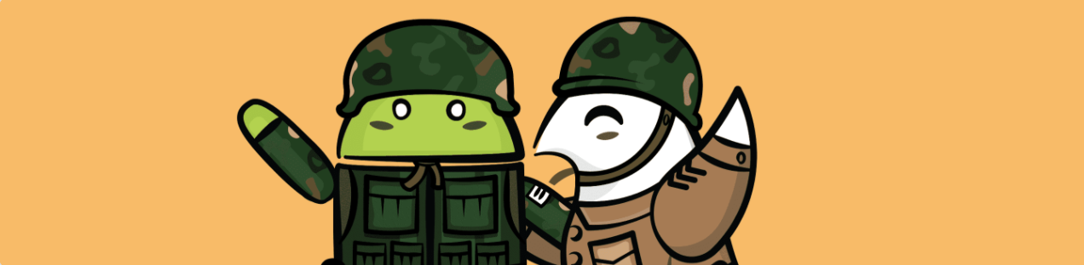

Android Bootcamp Challenge Three

## 

## Specifications

In this challenge you will create your very first Android app in Android Studio. Create a brand new project with the **Empty** template. Create a ‘Business Card’ or ‘Calling Card’ app for yourself or a fictional business. Include an image and contact information such as name, location, email address and/or telephone number. Include a button on the card that does something when it is tapped. An example would be to change some text or colors in the layout. Some ideas are:

* Display a random quote of text
* Toggle a color scheme from light to dark
* Make a counter that can count the number of contacts the card is shown to with the tap of a button
* An idea of your own is fine too!

Make sure the app can display correctly in landscape and portrait, you can even have a different layout for the screen configurations if you choose. Use a constraint layout or some nested layouts to achieve your design. Be sure to place color values in the **colors.xml**, appropriate text values into **strings.xml** and dimensions in **dimens.xml**. Be as creative as you like. This is your opportunity to get acquainted with the visual editor and constraint layout.

## My Example

Below are some screenshots of the example that I made. I created my app with inspirational quotes from [Living by the Code](https://store.raywenderlich.com/products/living-by-the-code). Each time the app loads, a unique, random quote is displayed. When the button is tapped, a new quote is displayed. When the app shifts from portrait to landscape, I retain the quote and do not generate a new one. In this way, the user can’t accidentally change orientation and lose the quote they were looking at before. I used a free online [logo generator](https://logomakr.com/) and the [color tool](https://material.io/resources/color/#!/) from the material design site to dress it up, although I’m not a designer, I did my best! :] I have used chaining on the constraint layout. I have used styles and styles with parent styles, and all my colors, dimensions and strings are in the appropriate .xml files. I’ve included a PR and some commits in my repo.

|  |  |
| --- | --- |
|  |  |

## Grading Criteria:

* The app must be your own, unique creation from scratch.
* All text, dimensions and colors are in the appropriate .xml file.
* App looks good in both portrait and landscape.
* App uses appropriate layouts to achieve a readable, attractive design.
* App has a button or control with a click listener and is interactive.
* App includes an image.
* The repo and pr request(s) are included correctly.

## Bonus Ideas:

* App has a menu to display the build version in a dialog.
* App has a ‘share’ option in the menu.
* App uses a style for common attributes on views.
* App persists some piece of information when the orientation changes.
* Add an animation to the button.
* Utilize material design components somewhere in the app.
* Any other creative additions you’d like to add based on what you’ve learned so far! Make it your own! I enjoy seeing how creative people can get with simplistic projects.

## Turn in Your Project

Upload your repo, create a PR, and email your mentor to let them know!

Filip: [filip@razeware.com](mailto:filip@razeware.com)

Fuad: [fuad@anaara.com](mailto:fuad@anaara.com)

Luka: [mrluka9@gmail.com](mailto:mrluka9@gmail.com)

Jenn: [reddunrogue@gmail.com](mailto:reddunrogue@gmail.com)

## Additional Fun Resources - Optional

### Constraint Layout Articles

Constraint Layouts part I by Fuad

<https://www.raywenderlich.com/9193-constraintlayout-tutorial-for-android-getting-started>

Constraint Layouts part II by Fuad

<https://www.raywenderlich.com/9475-constraintlayout-tutorial-for-android-complex-layouts>

### Some Material Design Resources

A video course about Material Design

<https://www.raywenderlich.com/7908751-introduction-to-google-s-material-design>

An article about Material Design

<https://www.raywenderlich.com/2780045-an-introduction-to-material-design-with-kotlin>

### Styles and Themes

An android dev summit talk about themes/styles in 2019

<https://www.youtube.com/watch?v=Owkf8DhAOSo&t=157s>